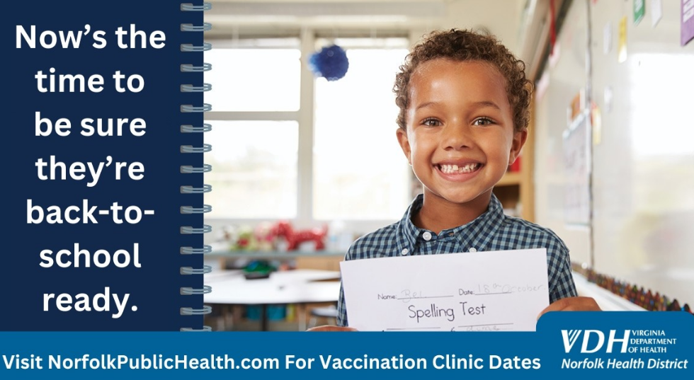

Norfolk Health Department
830 Southampton Ave., Norfolk, VA 23510

Back to School Vaccination Clinics:
- Monday, July 22nd - 9 am to 6 pm
- Wednesday, July 24th - 9 am to 6 pm
- Friday, July 26th - 9 am to 4 pm
- Monday, July 29th - 9 am to 6 pm
- Wednesday, July 31st - 9 am to 6 pm
- Friday, August 2nd - 9 am to 4 pm
- Monday, August 5th - 9 am to 6 pm
- Wednesday, August 7th - 9 am to 6 pm
- Monday, August 12th - 9 am to 6 pm
- Wednesday, August 14th - 9 am to 6 pm
- Friday, August 16th - 9 am to 4 pm
- Monday, August 19th - 9 am to 6 pm
- Wednesday, August 21st - 9 am to 6 pm
- Friday, August 23rd - 9 am to 4 pm
- Monday, August 26th - 9 am to 4 pm
- Wednesday, August 28th - 9 am to 4 pm
Norfolk Scope (Unity in the Community)
201 E. Brambleton Ave., Norfolk, VA 23510

Back to School Vaccination Clinics:
- Saturday, August 10th - 10 am to 2 pm



Norfolk Health Department
830 Southampton Ave., Norfolk, VA 23510

Back to School Vaccination Clinics:
- Monday, July 22nd - 9 am to 6 pm
- Wednesday, July 24th - 9 am to 6 pm
- Friday, July 26th - 9 am to 4 pm
- Monday, July 29th - 9 am to 6 pm
- Wednesday, July 31st - 9 am to 6 pm
- Friday, August 2nd - 9 am to 4 pm
- Monday, August 5th - 9 am to 6 pm
- Wednesday, August 7th - 9 am to 6 pm
- Monday, August 12th - 9 am to 6 pm
- Wednesday, August 14th - 9 am to 6 pm
- Friday, August 16th - 9 am to 4 pm
- Monday, August 19th - 9 am to 6 pm
- Wednesday, August 21st - 9 am to 6 pm
- Friday, August 23rd - 9 am to 4 pm
- Monday, August 26th - 9 am to 4 pm
- Wednesday, August 28th - 9 am to 4 pm
Norfolk Scope (Unity in the Community)
201 E. Brambleton Ave., Norfolk, VA 23510

Back to School Vaccination Clinics:
- Saturday, August 10th - 10 am to 2 pm

